(Approx. 857 words)

When is a Word Document not a Document?
By Nancy DeMarte, 1st Vice President, Sarasota Technology User Group, FL
April 2015 issue, Sarasota Technology Monitor
www.thestug.org
ndemarte (at) Verizon.net

When Word users type a document and save it, they usually don’t pay attention to that 3 or 4 letter extension at the end of the file name which indicates the file type. Nor do they realize they can save that document as a different file type. Why would they want to do this? One reason is to ensure that the people they send the document to can open it. Read on for a few more reasons.

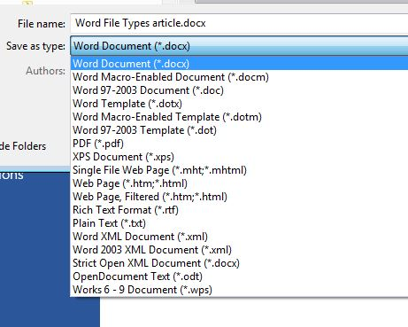
Windows 7 and 8 offer nearly 20 file types in which a document can be saved. To see this list, create a document and click File – Save As. When you get to the Save As dialog box, click the arrow next to “Save as type” to open the menu of Word file types, as shown below. It helps to get familiar with the few file types that home users may want to use in special situations.
File Type list in Word 2013

New and Old Word: Let’s begin with the incompatibilities between new and old versions of Word. Word 2003 and earlier versions used the .doc extension as the default for documents. Word 2007 and later versions use .docx. The rule is, newer versions of Word can open older documents, but older versions of Word can’t open newer documents. If you have Office 2013 and try to send a document email attachment to a friend with Office 2003, he will only be able to open your .docx if he has installed the free Microsoft Office Compatibility Pack from the microsoft.com download center. If he sends you a .doc, you can open it, but it opens in “compatibility mode,” which prevents you from using some of the features of your Word version until you convert it to a .docx (File – Convert). These are frustrating situations, but you can solve your problem by saving a copy of your document as a .doc before you send it.

Sharing Documents with People without Word: A few file types are helpful if you want to create a document that can be read both by Word users and those who do not have any version of Word. Rich Text Format (.rtf) can be read by almost any word-processing program and several operating systems. This is a good sending option if you don’t know what word-processing program a person uses. Another option is to compose your document in WordPad, a stripped down version of Word found on all Windows computers. Its default file type is .rtf..

Open Office compatibility: Word offers one file extension, .odt, OpenDocument Text, to enhance its compatibility with the popular free office suites, Open Office Writer, Google Docs and other open source applications. If you receive a document in .odt format, Word will let you open and save it, although the formatting may differ a bit from the original. If you send a Word document to an Open Office user, choosing the .odt file type will ensure it will arrive looking the way you intended.

Templates: Changing the file type also comes in handy if you use Word templates. A template is a preformatted document in which content can be customized and saved, leaving the template unchanged and ready for later use, as in the case with forms, resumes or flyers. Word has many templates built in or downloadable from within Word. You can modify a template from the gallery or create your own and save it with the template extension, .dot or .dotx, which makes it reusable.

Plain Text: The plainest and therefore most versatile of all the file types is .txt, Text format. It used to be called “flatfile” because of its lack of formatting and simple text. Often if you have a typed “chat” with a tech support person online and save the chat for future reference, it will be in .txt. You get no fancy formatting, but readable text.

Portable Document Format: By saving a document as a .pdf, you preserve all formatting, text, and graphics, making it unable to be edited without special software. Adobe, which established the standard for this format, offers Adobe Reader (free) for viewing and saving .pdf documents and Adobe Acrobat ($110 - $500) for creating them. Office 2007 introduced .pdf as a saving option for Word, Excel and PowerPoint. Word 2013 has recently added the ability not only to save a document in .pdf, but also to open a .pdf as an editable Word document. Microsoft adds a disclaimer that the result might not look exactly like the original, but the text will be intact. In my trials, I found the formatting to be quite close to the original, especially for short documents with a minimum of graphics.
Word 2013 has recently added the ability to open a .pdf as an editable Word document.

One last tip: Always save your document as a .docx or .doc first, before changing the file type. That way you will always be compatible with your own documents.

